https://www.mentesenblanco-razonamientoabstracto.com

Domino Series Test 3

By Omar Castaño P.
You will find the correct answers at the end of the test.
Change the token with the question marks (??) for one of the three possible answers (a, b, c):

- 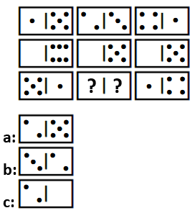
2. 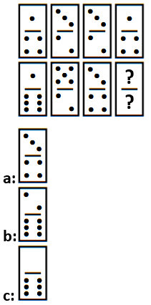
3. 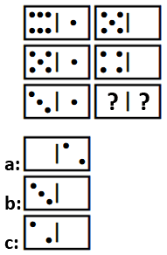
4. 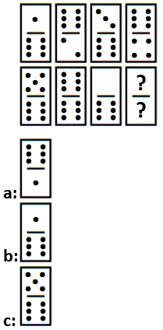
5. 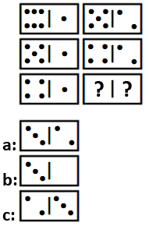
6. 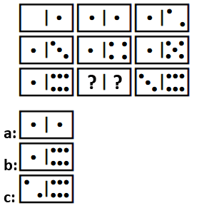

Answers: (01.b) (02.a) (03.c) (04.a) (05.a) (6.c)

